Ambient Light

📘 Definition
# Source: AI Source: Provided by: [Data Path: Persons Table -> ID Column: 1, Name_En Column: Motasem Essam] -> From: [ChatGPT] on [5/2/2026]
Ambient Light is a type of light in computer graphics that provides general, uniform illumination to all objects in a scene. It does not come from a specific direction or position.

🌫️ How Ambient Light works
# Source: AI Source: Provided by: [Data Path: Persons Table -> ID Column: 1, Name_En Column: Motasem Essam] -> From: [ChatGPT] on [5/2/2026]
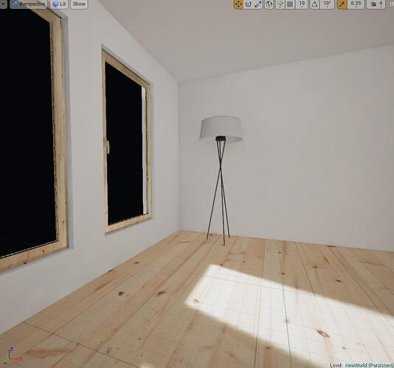
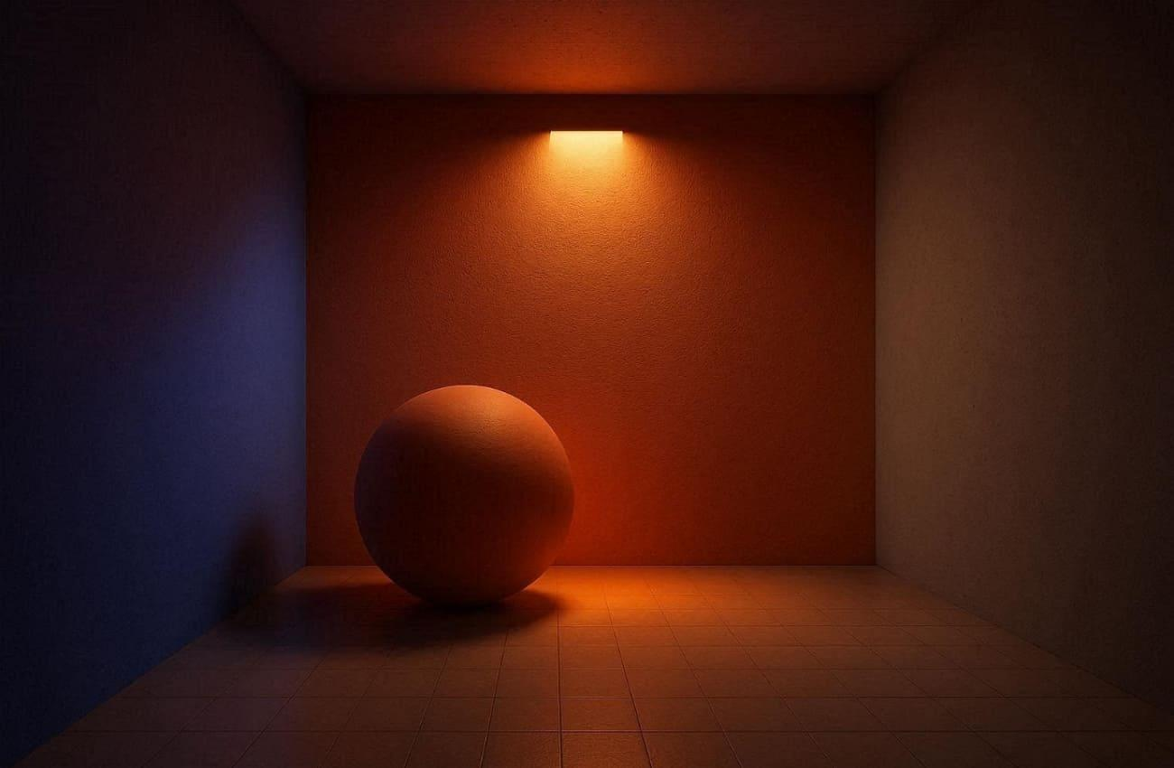
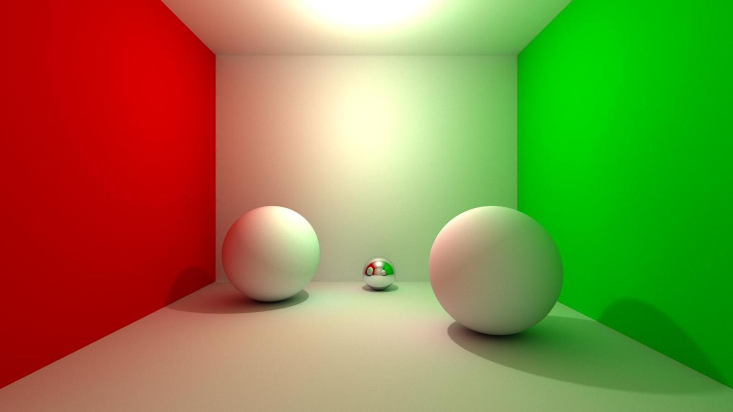
- Lights up everything equally
- Has no direction
- Does not create shadows
- Prevents objects from being completely dark

🧠 Simple example
# Source: AI Source: Provided by: [Data Path: Persons Table -> ID Column: 1, Name_En Column: Motasem Essam] -> From: [ChatGPT] on [5/2/2026]
Think of:
- 🌆 Light in a room even when no lamp is directly shining on an object
- 🌥️ A cloudy day where light is spread everywhere
Even without direct light, you can still see objects—that’s ambient light.

🎮 Where Ambient Light is used
# Source: AI Source: Provided by: [Data Path: Persons Table -> ID Column: 1, Name_En Column: Motasem Essam] -> From: [ChatGPT] on [5/2/2026]
- 🎮 Video games (to avoid totally dark areas)
- 🎬 3D animation and movies
- 🧑‍🎨 Digital art and rendering
- 🏗️ Architectural visualization

⚙️ Key features
# Source: AI Source: Provided by: [Data Path: Persons Table -> ID Column: 1, Name_En Column: Motasem Essam] -> From: [ChatGPT] on [5/2/2026]
- 🌐 Affects the entire scene
- 🚫 No shadows or highlights
- 💡 Soft and low-intensity light
- 🔧 Usually combined with other lights (point, directional, spot)

🚀 In short:
# Source: AI Source: Provided by: [Data Path: Persons Table -> ID Column: 1, Name_En Column: Motasem Essam] -> From: [ChatGPT] on [5/2/2026]
Ambient Light = soft, global light that illuminates everything evenly without direction or shadows.

